2024
Hippology Review 16 – 19 year olds
Source: HORSE & HORSEMANSHIP
** Know the part of the: Horse (pg. 8) Bits (Pelham, Bar, Dee Ring) (pg. 30)
All 4 Bridles (pg. 28) All 3 Saddles (pg. 31,32,33)
Pg. 4-5 1. Name the 5 major variations to coat color.

Pg. 10 2. The ____________________must be short, and strongly muscled because it supports the weight of
the saddle and rider, and lifts the forequarters when the hose is in motion.

Pg. 10-11 3. The shoulder should be set at an angle of about _______________degrees, this is also true for the
front ___________________________________________.

Pg. 20 4. _________________________ is the art of riding the horse and of understanding its needs.

Pg. 23 5. In the canter which leg would you apply pressure with to obtain a left lead?

Pg. 33 6. Saddle blankets or pads serve at least 4 purposes. What are they?

Pg. 34 7. What is a martingale used for?

Pg. 35 8. What does hogged mean?

Pg. 35 9. What does bloom mean?

Pg. 36 10. A ______________________________horse is neither hot to the touch nor breathing hard.

2024
Hippology Review 16 – 19 year olds
Pg. 48 11. Be able to label the 13 parts of the hoof.

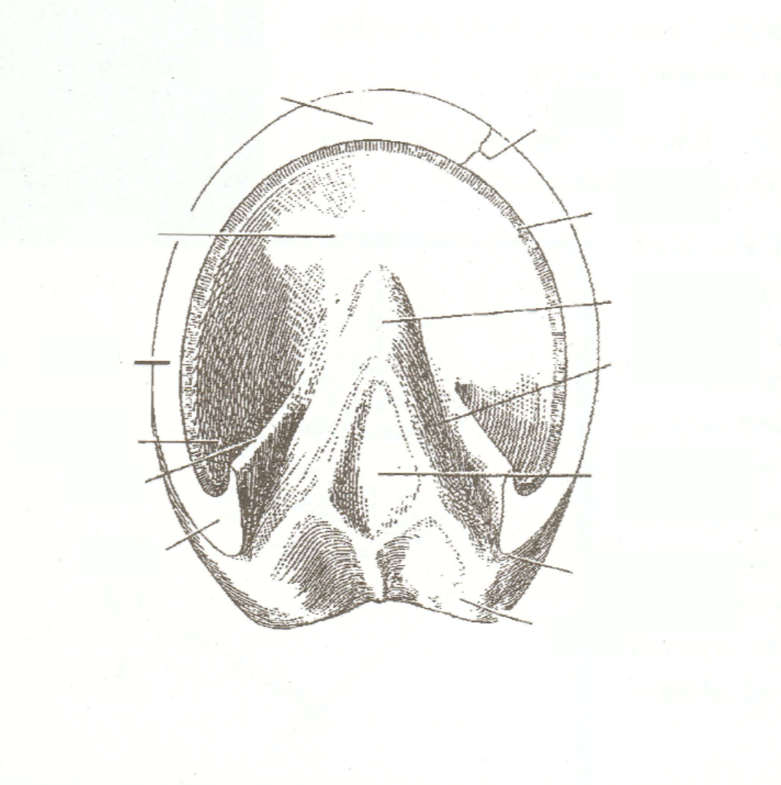

Pg. 54 12. What is the main objective before starting a jump?

Pg. 54 13. When should you discipline your horse for bad behavior?

Pg. 54 14. Always treat other people on horse and on foot in the same way that you would like to be treated.
True or False
Pg Appendix B 15. What is a hot-blooded horse?

Source: 4H HORSE JUDGING GUIDE
Pg. 3 16. When judging a horses there are 9 points to be considered. What are the?

Pg. 3 17. Correctness of feet and leg are a basic _______________to all breeds and types of horses?

2024
Hippology Review 16 – 19 year olds
Source: 4H HORSE JUDGING GUIDE
Pg. 13, 15, 16 18. What do these horse judging terms describe: a fault or the ideal?
- Sharper at the withers on the front-end fault or ideal
- Light waisted body fault or ideal
- Squarer-placed legs fault or ideal
- Buckles on ankles and pastern fault or ideal

Source: EXTERNAL PARASITES OF HORSES
Pg. 7 19. It’s best to keep the same active ingredients in your fly spray?
True or False

Pg. 13 20. What is the most important characteristic of the mosquito with regard to horses?

Pg. 16 21. What is the most important tool in the management of stable flies?

Pg. 16 22. The most common site for developing stable fly larvae is in mixtures of manure and bedding left in stalls and frequently rewetted with urine.
True or False
Pg. 21 23. Face flies feed of the ____________________from the eyes and nostrils of horses as well as on _______________________from other wounds.

Source: HORSE SCIENCE
Pg. 23 24. In the female reproductive system, what is the very thin membrane shaped like funnel
called?

Pg. 45 25. What 3 things must you protect your horse from most?

Pg. 47 26. _________________________is a means of artificially stimulating the immune system of your horse without giving it an actual disease.

2024
Hippology Review 16 – 19 year olds
Source: HORSE SCIENCE
Pg. 47 27. The rabies virus is eliminated through the _____________________of your horse.

Pg. 50 28. This milder and more common type of colic is often associated with overexcitement and
sudden diet changes. ________________________________________________

Pg. 52 29. Name the 4 stages of the life cycle of a fly.

Source: HORSE & PONY RULES & REGULATIONS
Pg. 2 30. Under what circumstances can you continue a class with broken equipment?

Pg. 4-6 31. In showmanship, will you be penalized for hair left inside the horses’ ears? Why?

Pg. 8 32. What age animals (horses) are eligible to be shown in lunge line division?

Pg. 11 33. How do you dismount a horse in the English Riding Division?

Pg. 19 34. Know the Dressage test score card.

Pg. 19 35. In Dressage voice signals are permitted. True or False

Pg. 28 36. What are the last 3 steps in Reining pattern #2?

Pg. 31 37. Any backing obstacles must be spaced a minimum of _____________inches apart.

2024
Hippology Review 16 – 19 year olds
Source: HORSE & PONY RULES & REGULATIONS
Pg. 34 38. Know the points taken away for each penalty in the English/Western Riding Division.
5 points:__________________________________________________________
3-5 points:________________________________________________________
3 points:_________________________________________________________

2 points:__________________________________________________________

1 point:__________________________________________________________

½ point:__________________________________________________________

Pg. 35 39. In the Driving Division, name an optional piece of equipment.

Pg. 36 40. A _________________________________horse is more suitable for a formal vehicle in the Driving Division.

Pg. 35 41. Name the 4 gaits called for in a Pleasure Driving Class.

Pg. 37 42. In Gymkhana the riders appointments may be ______________________depending on the tack being used but cannot be a _________________________of both.

2024
Hippology Review 16 – 19 year olds
Pg. 38 43. Name the 6 events in the Gymkhana Division.

Pg. 41 44. An assistant to the exhibitor in a halter class who encourages draft horses & donkeys to move out energetically is called a _____________________________________.
Source: TRAILERING GUIDE
Pg. 2 45. Trailering can put your horse at a greater risk for illness and injury, especially
______________, __________________, _________________, _________________
Pg. 14 46 Complete the following tips: when pulling a trailer
- Accelerate and Brake_____________________________Why?

- Execute turns with _____________________________Why?

- Allow for double or more_________________________when hauling a load.

2024
Hippology Review 16 – 19 year olds
Source: PAMPHLETS:
Fill in the Blanks
Name of  Illness/Disease | EIA  Equine Infectious Anemia | EPM  Equine Protozoal Myeloencephalitis | Equine Influenza
How is it Transmitted | 47. | birds give to opossums | 48.
System/Area it Affects | 49. | 50. | respiratory system
Signs | 51. | Stiff, tilted movements; lameness; incoordination weakness; paralysis of eye, face, mouth; difficult swallowing; seizures collapses, sweating; not always on the same side | 52.
Treatment | Euthanize; ship to slaughter; move to insect free enclosure & quarantine; move ¼ mile away from ALL equine | 53. | Rest; supportive care; well ventilated stalls, antibiotics
Prevention | Coggins test; reduce flies; avoid exposing to affected animals; do not share saddles, bridles, etc between horses with open or bleeding wounds | 54. | 55.

